### CSS tags

### CSS Backgrounds

Define sizes of multiple background images

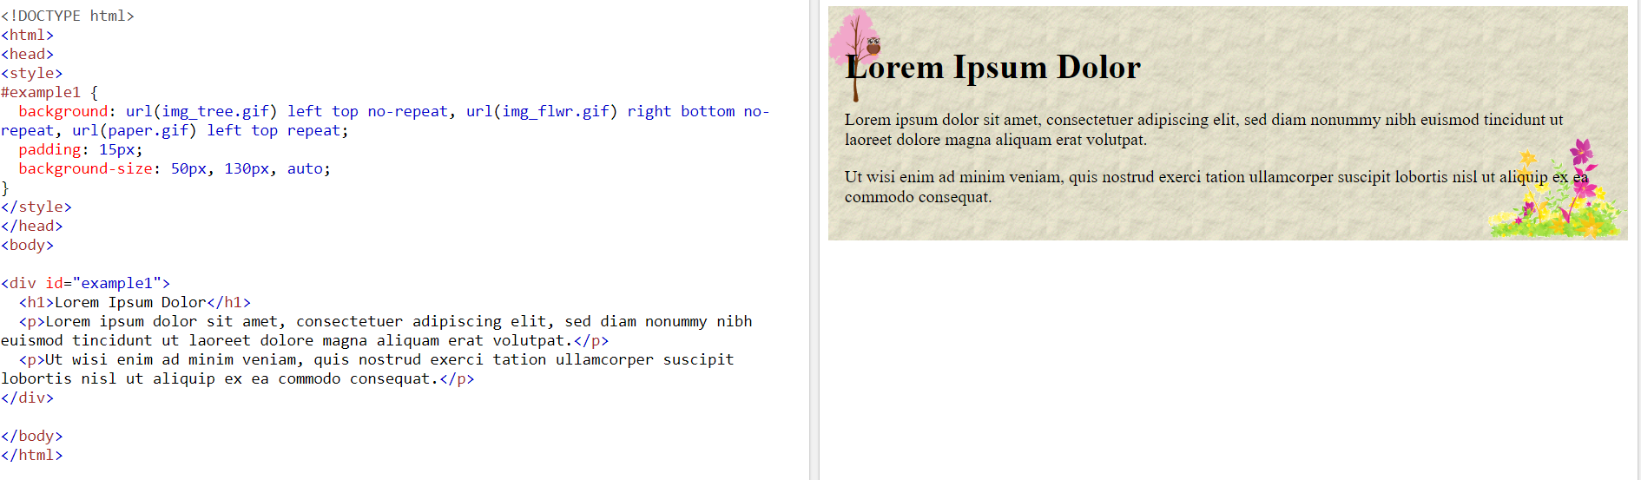

<https://www.w3schools.com/css/tryit.asp?filename=trycss3_background_multiple3>

### CSS Multiple Columns

Specify a suggested, optimal width for the columns

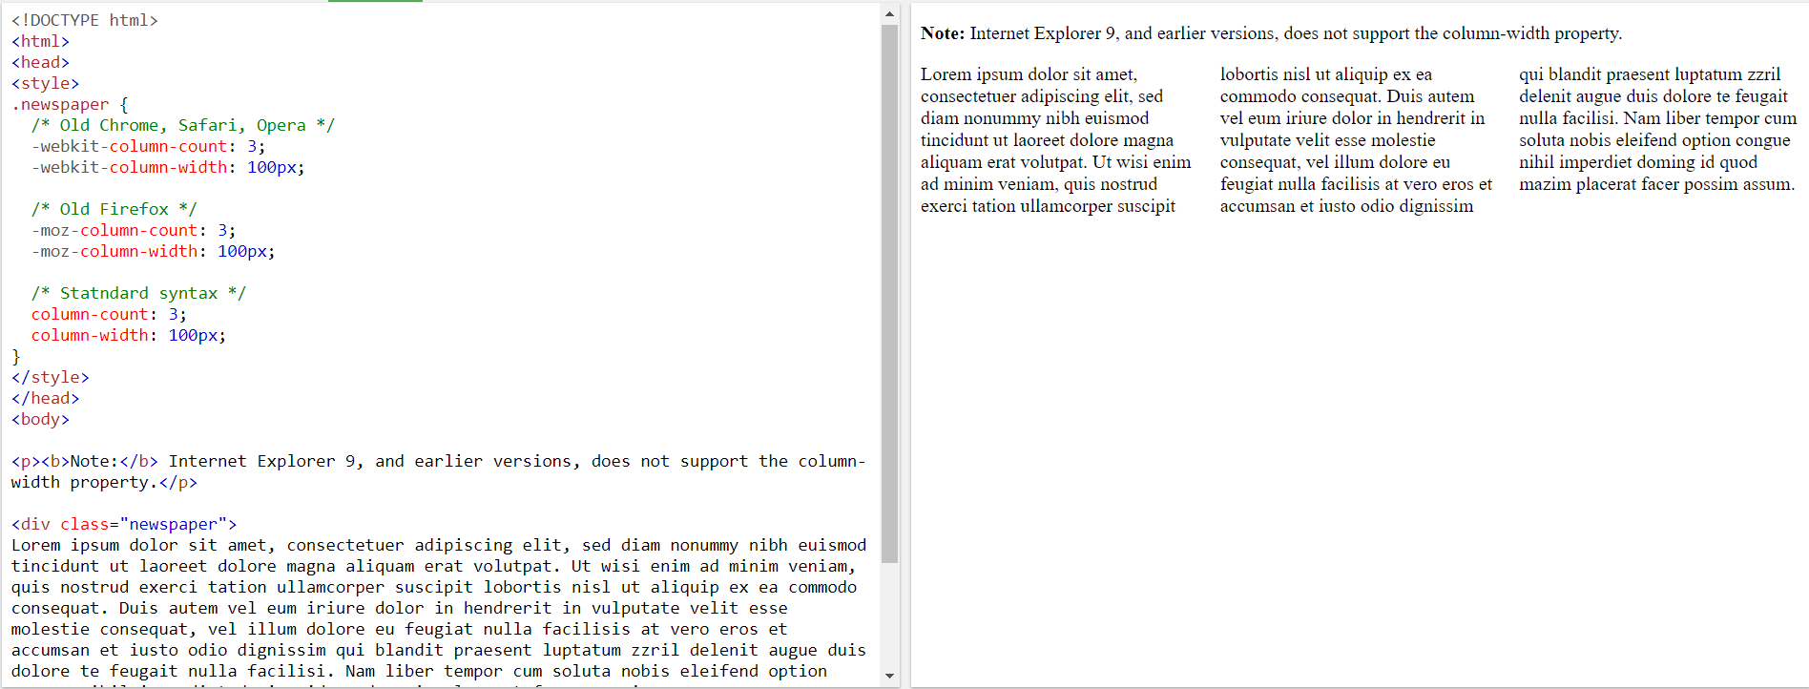

<https://www.w3schools.com/css/tryit.asp?filename=trycss3_column-width>

### CSS Box Sizing

Form elements + box-sizing

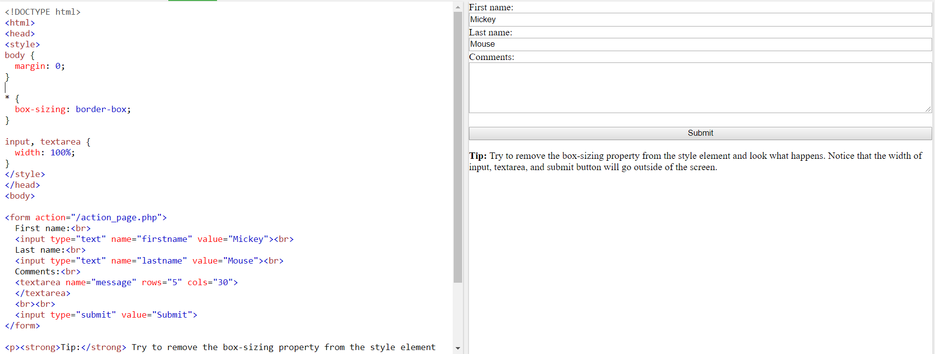

<https://www.w3schools.com/css/tryit.asp?filename=trycss3_box-sizing_all>

# CSS Iframe:

Same as the video property, but you can add videos from the internet

# outline-color:

to change the color of the outline of a border